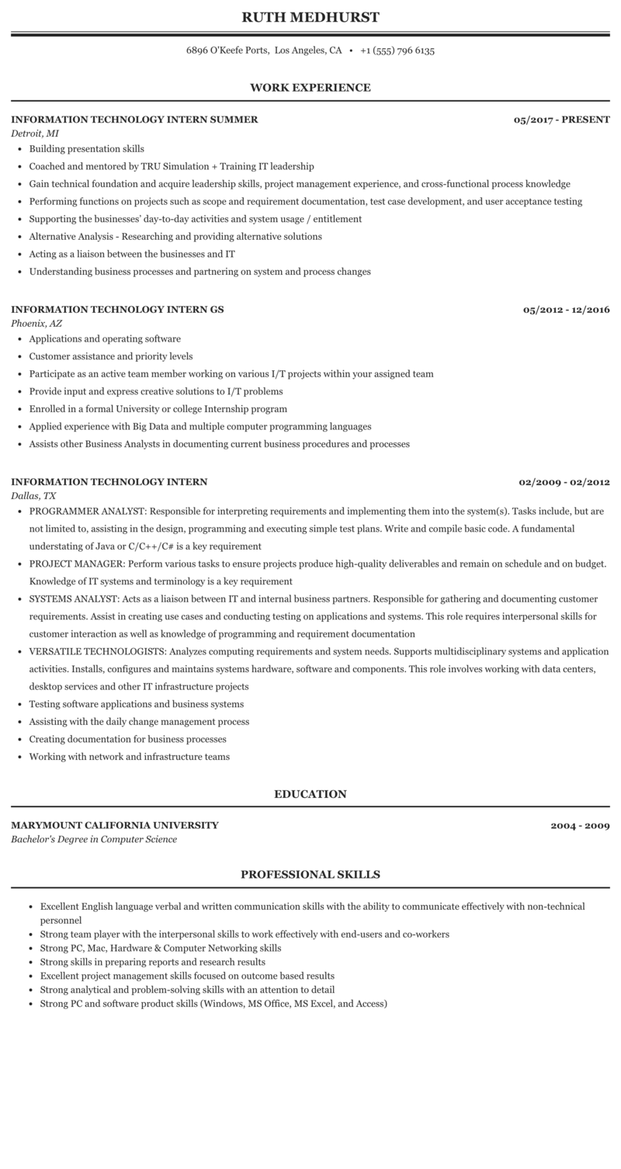
RUTH MEDHURST
6896 O'Keefe Ports, Los Angeles, CA +1 (555) 796 6135
WORK EXPERIENCE
INFORMATION TECHNOLOGY INTERN SUMMER
Detroit, MI
• Building presentation skills
⚫ Coached and mentored by TRU Simulation + Training IT leadership
05/2017-PRESENT
⚫ Gain technical foundation and acquire leadership skills, project management experience, and cross-functional process knowledge
• Performing functions on projects such as scope and requirement documentation, test case development, and user acceptance testing
• Supporting the businesses' day-to-day activities and system usage / entitlement
⚫ Alternative Analysis - Researching and providing alternative solutions
• Acting as a liaison between the businesses and IT
• Understanding business processes and partnering on system and process changes
INFORMATION TECHNOLOGY INTERN GS
Phoenix, AZ
⚫ Applications and operating software
• Customer assistance and priority levels
• Participate as an active team member working on various I/T projects within your assigned team
• Provide input and express creative solutions to I/T problems
⚫ Enrolled in a formal University or college Internship program
⚫ Applied experience with Big Data and multiple computer programming languages
• Assists other Business Analysts in documenting current business procedures and processes
05/2012-12/2016
INFORMATION TECHNOLOGY INTERN Dallas, TX
02/2009-02/2012
• PROGRAMMER ANALYST: Responsible for interpreting requirements and implementing them into the system(s). Tasks include, but are not limited to, assisting in the design, programming and executing simple test plans. Write and compile basic code. A fundamental understating of Java or C/C++/C# is a key requirement
• PROJECT MANAGER: Perform various tasks to ensure projects produce high-quality deliverables and remain on schedule and on budget. Knowledge of IT systems and terminology is a key requirement
⚫ SYSTEMS ANALYST: Acts as a liaison between IT and internal business partners. Responsible for gathering and documenting customer requirements. Assist in creating use cases and conducting testing on applications and systems. This role requires interpersonal skills for customer interaction as well as knowledge of programming and requirement documentation
⚫ VERSATILE TECHNOLOGISTS: Analyzes computing requirements and system needs. Supports multidisciplinary systems and application activities. Installs, configures and maintains systems hardware, software and components. This role involves working with data centers, desktop services and other IT infrastructure projects
• Testing software applications and business systems
• Assisting with the daily change management process
• Creating documentation for business processes
• Working with network and infrastructure teams
MARYMOUNT CALIFORNIA UNIVERSITY Bachelor's Degree in Computer Science
EDUCATION
PROFESSIONAL SKILLS
2004-2009
• Excellent English language verbal and written communication skills with the ability to communicate effectively with non-technical personnel
• Strong team player with the interpersonal skills to work effectively with end-users and co-workers
• Strong PC, Mac, Hardware & Computer Networking skills
• Strong skills in preparing reports and research results
• Excellent project management skills focused on outcome based results
⚫ Strong analytical and problem-solving skills with an attention to detail
• Strong PC and software product skills (Windows, MS Office, MS Excel, and Access)

